LMX2594 Output Power
Introduction
The setup conditions for measurement of output power are key. This document describes the setup conditions used to achieve the numbers as reported in the datasheet. There are a few key points to keep in mind:
- Output power in datasheet has losses de-embedded.
- The LMX2594 EVM routing is sub-optimal for output power.
- Output power setting for OUTx_PWR is non-linear and has a discontinuity between 31 and 32.
- Output power will be lost due to bad match

LMX2594 Datasheet Output Power
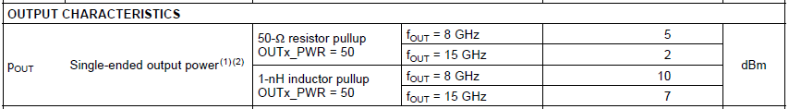
The numbers reported in the datasheet assume that the losses are de-embedded and that the load is matched.
Board Used for Output Power
The placement for the pull-up component is absolutely critical and must be close to the chip or else there is loss in output power. However, the LMX2594EVM accommodates many features including differential outputs. For the best possible output power measurement, it is better to use a single-ended routing and take the complimentary side to 50 ohm on the back side of the board as done in reference design TIDA-01410. Note in layout that pullup is as close as possible. Also best possible connector and decoupling capacitor is used.
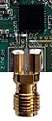
Matching the Load
If the load is not matched, then there is loss of power. The matching may change with frequency. In the case of the resistor pull-up, the matching helped only slightly. However, in the case of the inductor pull-up, the output impedance is far from 50 ohms and matching is not very good. In both cases, a sliding microwave tuner was used from Maury Microwave.
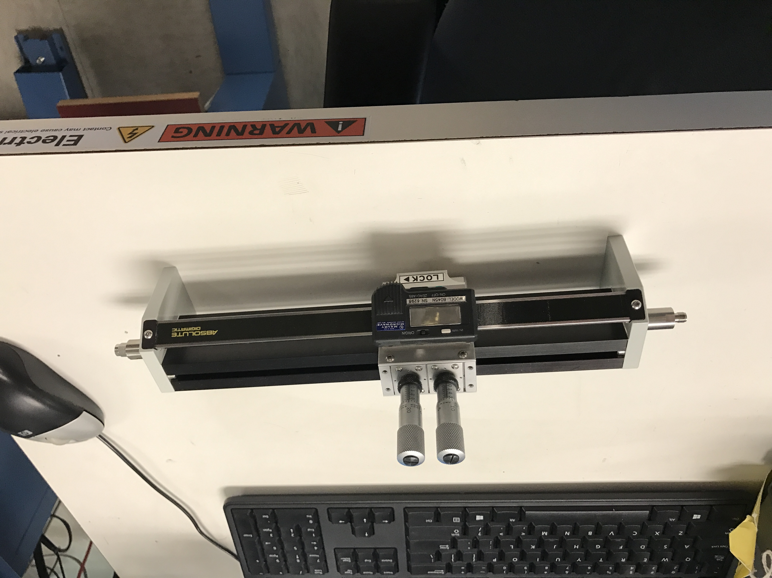

Determining the Loss due to SMA Connectors on the board and Traces on the Board
For the actual measurement, a signal generator of known power and frequency was attached to the E5053 and the signal generator frequency was swept.
The next step was to repeat this with a specialized board that had one output that was two copies of the output trace placed back to back and including the SMA connectors. Then this was connected with a barrel connector that was assumed to have no loss. The change in the output power observed on the E5053 is therefore twice the loss.

The actual board used was specialized for this purpose and served many functions, but a diagram of this is shown below. Note that he path on the far right is twice the length of the path attached to the LMX2594.

The loss of this board was measured over frequency and it was found to be about 0.2 dB. Although this board was not the dual PLL board (TIDA-01410), the PLL on it was a copy of this layout and therefore it can be assumed that the losses would be the same.

Measurements for Resistive Load
50 ohm Resistor Pull-Up
Fvco | OUTA_PWR | Measure | Board Loss | Tuner Loss | Connector Saver | Output Power
3000 | 50 | 7.7 | 0.2 | 0.1 |  | 8.0
4000 | 50 | 8.8 | 0.2 | 0.1 |  | 9.1
5000 | 50 | 8.6 | 0.2 | 0.2 |  | 9.0
6000 | 50 | 6.6 | 0.2 | 0.2 |  | 7.0
7000 | 50 | 3.2 | 0.2 | 0.2 |  | 3.6
8000 | 50 | 4.7 | 0.2 | 0.3 |  | 5.2
9000 | 50 | 3.8 | 0.2 | 0.3 |  | 4.3
10000 | 50 | 2.3 | 0.2 | 0.3 | 0.1 | 2.9
11000 | 50 | 3 | 0.2 | 0.4 | 0.2 | 3.8
12000 | 50 | 1.7 | 0.2 | 0.4 | 0.3 | 2.6
13000 | 50 | 2.8 | 0.2 | 0.4 | 0.4 | 3.8
14000 | 50 | 3.1 | 0.2 | 0.5 | 0.4 | 4.2
15000 | 50 | 1 | 0.2 | 0.5 | 0.5 | 2.2

1 nH Inductor Pull-Up
Fvco | OUTA_PWR | Measure | Board Loss | Tuner Loss | Connector Saver | Output Power
3000.0 | 50 | 10.6 | 0.2 | 0.1 |  | 10.9
4000.0 | 50 | 11.9 | 0.2 | 0.1 |  | 12.2
5000.0 | 50 | 12.1 | 0.2 | 0.2 |  | 12.5
6000.0 | 50 | 10.6 | 0.2 | 0.2 |  | 11.0
7000.0 | 50 | 7.9 | 0.2 | 0.2 |  | 8.3
8000.0 | 50 | 9.4 | 0.2 | 0.3 |  | 9.9
9000.0 | 50 | 8.5 | 0.2 | 0.3 |  | 9.0
10000.0 | 50 | 7.6 | 0.2 | 0.3 | 0.1 | 8.2
11000.0 | 50 | 6.8 | 0.2 | 0.4 | 0.2 | 7.6
12000.0 | 50 | 6.2 | 0.2 | 0.4 | 0.3 | 7.1
13000.0 | 50 | 6.1 | 0.2 | 0.4 | 0.4 | 7.1
14000.0 | 50 | 6.2 | 0.2 | 0.5 | 0.4 | 7.3
15000.0 | 50 | 5.6 | 0.2 | 0.5 | 0.5 | 6.8

Note that this matches the datasheet claims fairly closely.

